Political Reach on Twitter Without the Political Advertising

We looked at the quantitative and qualitative data of some of this year’s most popular politician’s and Presidential candidates to find out how they all compare.

Story and data by **x** & **y**

Code and design by **a** & **z**

**December 2019**

On October 30th, 2019, Twitter’s CEO, Jack Dorsey announced that Twitter will stop accepting political ads to reduce significant risk to politics.

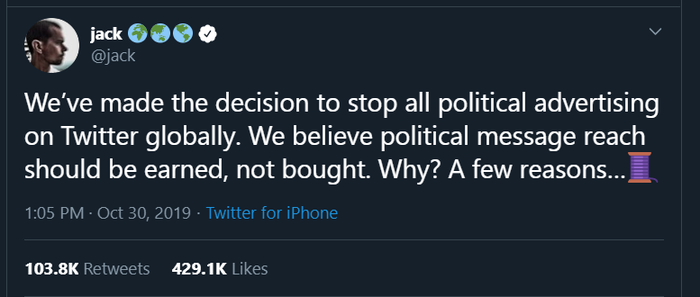

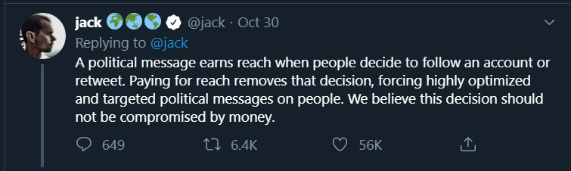

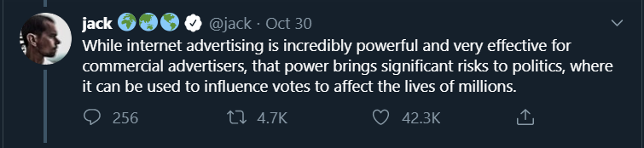

The announcement comes amid the scrutiny of social media companies’ handling of political ads. Large social media companies, such as Facebook, have been criticized for allowing politicians to run false advertisements.

This decision puts Twitter at odds with other social media companies that have defended their policies of not fact-checking political ads.